Technical Questions 2

Continuous integration vs. continuous delivery vs. continuous deployment (DevOps)

Continuous integration
Developers practicing continuous integration merge their changes back to the main branch as often as possible. The developer's changes are validated by creating a build and running automated tests against the build. By doing so, you avoid the integration hell that usually happens when people wait for release day to merge their changes into the release branch.
Continuous integration puts a great emphasis on testing automation to check that the application is not broken whenever new commits are integrated into the main branch.
Continuous delivery
Continuous delivery is an extension of continuous integration to make sure that you can release new changes to your customers quickly in a sustainable way. This means that on top of having automated your testing, you also have automated your release process and you can deploy your application at any point of time by clicking on a button.
In theory, with continuous delivery, you can decide to release daily, weekly, fortnightly, or whatever suits your business requirements. However, if you truly want to get the benefits of continuous delivery, you should deploy to production as early as possible to make sure that you release small batches that are easy to troubleshoot in case of a problem.
Continuous deployment
Continuous deployment goes one step further than continuous delivery. With this practice, every change that passes all stages of your production pipeline is released to your customers. There's no human intervention, and only a failed test will prevent a new change to be deployed to production.
Continuous deployment is an excellent way to accelerate the feedback loop with your customers and take pressure off the team as there isn't a Release Day anymore. Developers can focus on building software, and they see their work go live minutes after they've finished working on it.

Continuous integration
What you need (cost)
- Your team will need to write automated tests for each new feature, improvement or bug fix.
- You need a continuous integration server that can monitor the main repository and run the tests automatically for every new commits pushed.
- Developers need to merge their changes as often as possible, at least once a day.
What you gain
- Less bugs get shipped to production as regressions are captured early by the automated tests.
- Building the release is easy as all integration issues have been solved early.
- Less context switching as developers are alerted as soon as they break the build and can work on fixing it before they move to another task.
- Testing costs are reduced drastically – your CI server can run hundreds of tests in the matter of seconds.
- Your QA team spend less time testing and can focus on significant improvements to the quality culture.
Continuous delivery
What you need (cost)
- You need a strong foundation in continuous integration and your test suite needs to cover enough of your codebase.
- Deployments need to be automated. The trigger is still manual but once a deployment is started there shouldn't be a need for human intervention.
- Your team will most likely need to embrace feature flags so that incomplete features do not affect customers in production.
What you gain
- The complexity of deploying software has been taken away. Your team doesn't have to spend days preparing for a release anymore.
- You can release more often, thus accelerating the feedback loop with your customers.
- There is much less pressure on decisions for small changes, hence encouraging iterating faster.
Continuous deployment
What you need (cost)
- Your testing culture needs to be at its best. The quality of your test suite will determine the quality of your releases.
- Your documentation process will need to keep up with the pace of deployments.
- Feature flags become an inherent part of the process of releasing significant changes to make sure you can coordinate with other departments (Support, Marketing, PR...).
What you gain
- You can develop faster as there's no need to pause development for releases. Deployments pipelines are triggered automatically for every change.
- Releases are less risky and easier to fix in case of problem as you deploy small batches of changes.
- Customers see a continuous stream of improvements, and quality increases every day, instead of every month, quarter or year.

One of the traditional cost associated with continuous integration is the installation and maintenance of a CI server. But you can reduce significantly the cost of adopting these practices by using a cloud service like Bitbucket Pipelines which adds automation to every Bitbucket repository. By simply adding a configuration file at the root of your repository you will be able to create a continuous deployment pipeline that gets executed for every new change pushed to the main branch.
Pipelines: The goal of Continuous Delivery is to enable a constant flow of changes into production via an automated software production line. The Continuous Delivery pipeline is what makes it all happen.
There is no such thing as The Standard Pipeline, but a typical CD pipeline will include the following stages: build automation and continuous integration; test automation; and deployment automation.
What is DevOps? DevOps is a set of practices that automates the processes between software development and IT teams, in order that they can build, test, and release software faster and more reliably (less bugs, more stable).
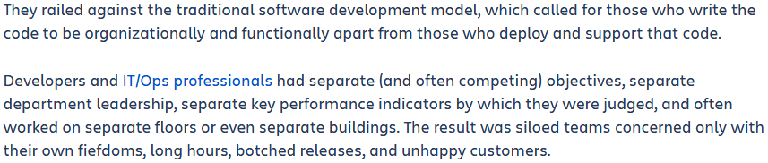

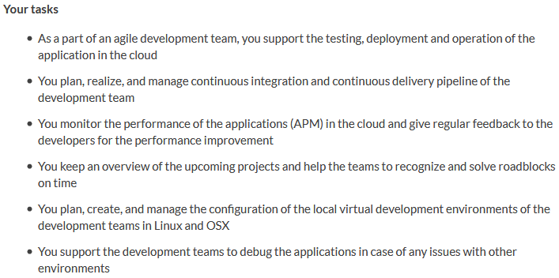
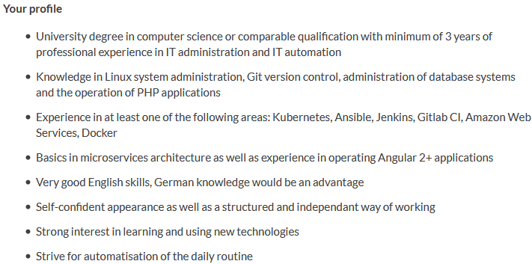

Mobile App versions (Web-App, Hybrid, Native, Almost Native)
4 Types of Mobile Apps

Web Apps / Mobile Websites: Built using standard web technology (HCJ), runs inside a browser, build like a regular website. The only difference is that they are built to look good and function well on mobile devices. Means they are responsive, they were designed with the Mobile First Approach: starting to design focusing mobile first, then also developing the desktop version.
- Easy to build, no need to learn different technologies, any developer can build a simple mobile website. You can use any web technology or language you want.
- Easy to maintain/host.
- By far the cheapest option. Once because the web developers are much cheaper to hire and secondly you can have a single application for all platforms.

- Need to run in a browser. No icon on desktop. The user experience is bad because they need to open the internet app, type the url of the app.
- Slower than native apps. Native apps are created and optimized for that specific device.
- Less interactive, less intuitive. Less options for animations etc.
- Cannot be submitted to app store
- Cannot interact with device utilities. No api for camera, geo location …

Native Apps: Most common type of mobile app. Built for specific platform. Build using native programming language.
- Very fast because built specifically for the platform
- Much more interactive and intuitive. Easily interact with all the API of the platform.
- Distribution is easier because of the market app

- Single platform. Need to develop for many platforms (Android, IOS, Windows, Blackberry...)
- Languages are harder to learn. That’s why hiring developers are expensive. Hard to maintain
- Makes is difficult for startups or small companies

Hybrid Mobile Apps: Combination of native & web apps. Use the standard web stack (HCJ). Runs inside a container/webview.
- Easy to build. You need a single app for all platforms. Thats why much cheaper and faster than native
- No browser needed. Can be published on appstore. Exactly like a normal application
- Can usually access device utilities using the API

- Slower than native apps. Might be less interactive. Can feel clunky but frameworks / wrappers are getting better
- More expensive than web apps, you need that wrapper framework. But still hybrid apps are highly preferred over web apps unless desktop is a big focus.

Almost (Fake) Native Apps: Apps built with web technology but convert the app into native components instead of just wrapping it with a web view.
React Native (facebook - JavaScript), Flutter (google - Dart), Xamarin (microsoft - C#).
- Very close to a real native app in term of performance

-> CDN? I have a web app, how do I work with a CDN, which files will go to CDN, which files stay at my host, where does my WAR file go?
Java SE vs Java EE
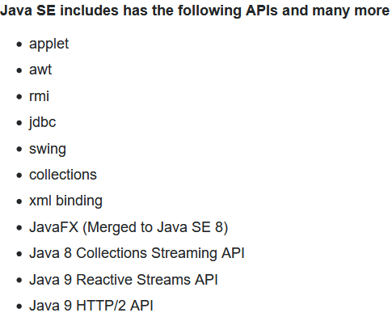
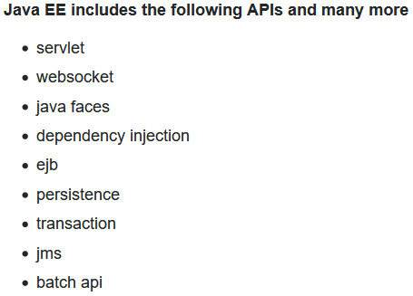

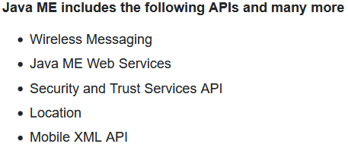

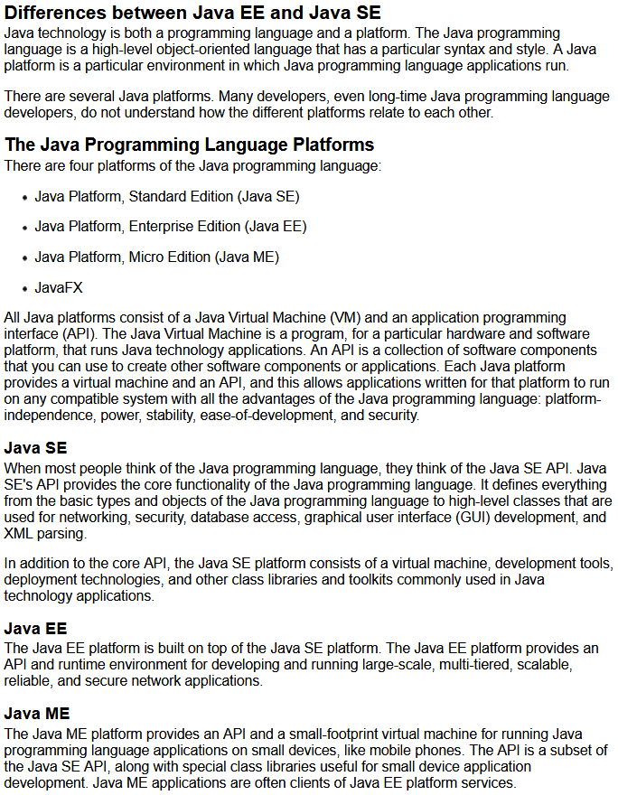
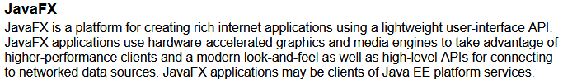
Java Bean vs Enterprise Java Bean (EJB)
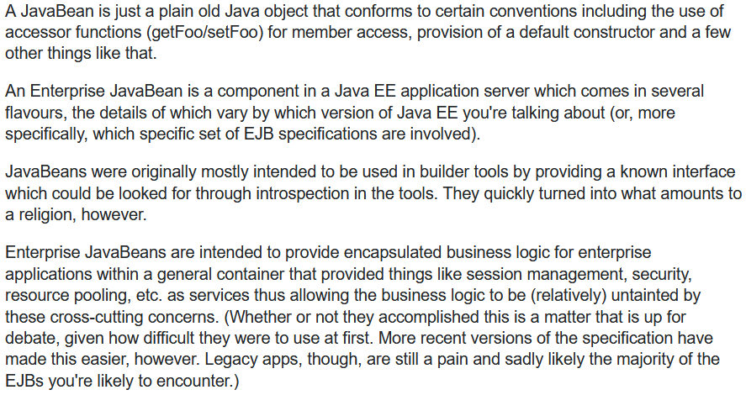

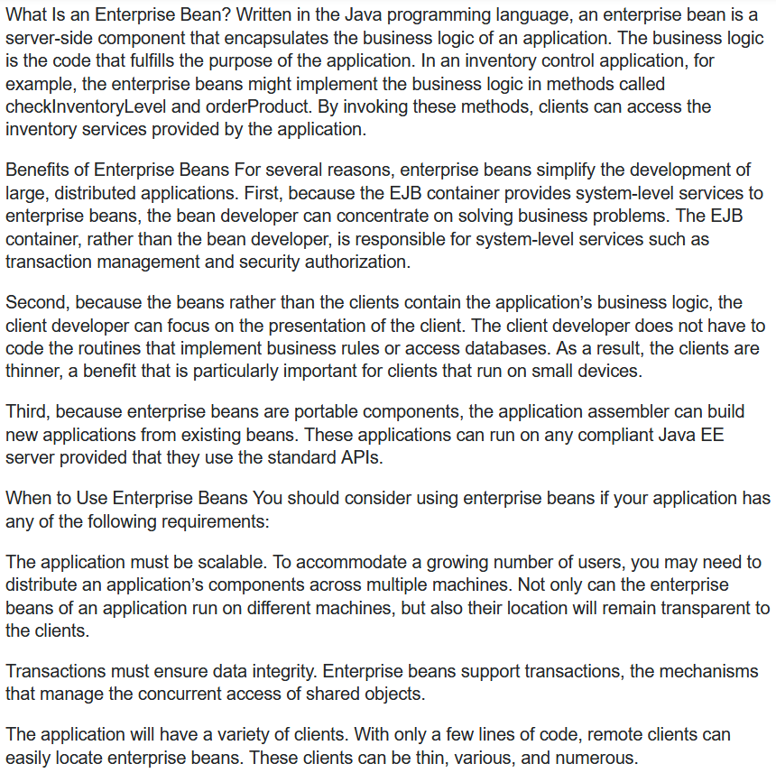

JVM – JRE – JDK - Java SDK

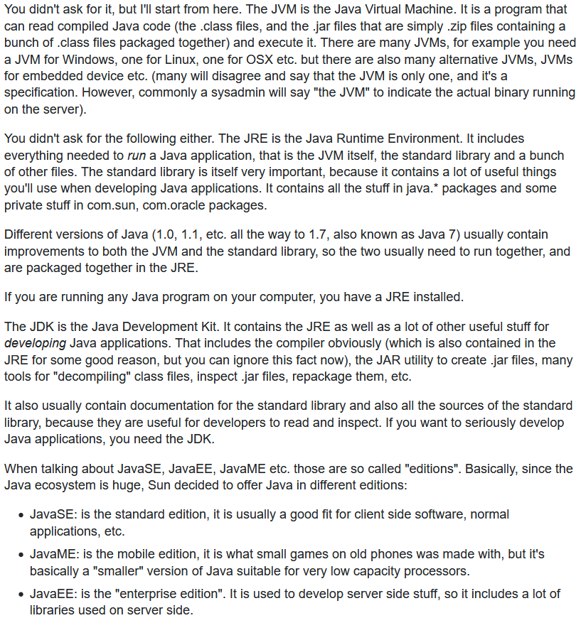

JDK – Java SDK
